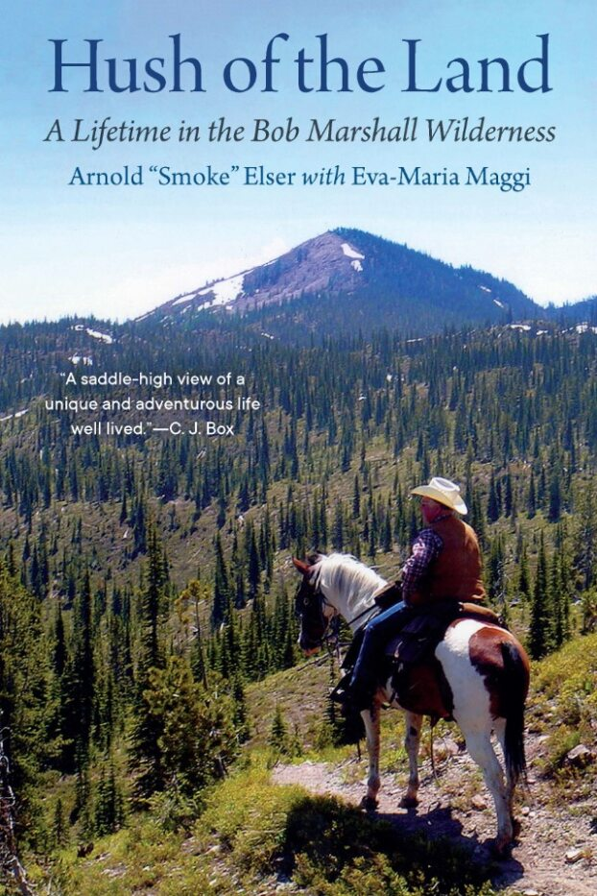
FOR IMMEDIATE RELEASE
ATTENTION:
Books, Montana, Outdoors

EVENT CONTACT:
[your contact]

[EVENT LOCATION] [EVENT date] WITH HUSH OF THE LAND AUTHORS
In Arnold “Smoke” Elser’s and Eva-Maria Maggi’s HUSH OF THE LAND (Bison Books, 2024), conservationist, packer, and outfitter Smoke Elser chronicles his six-decade quest to protect wild lands by bringing thousands of people deep into the mountains of Montana on horseback. With limited financial means and while still in college, the young man from Ohio decided against a promising career in forestry and chose instead to share his love of wilderness with city dwellers by working as a professional outfitter. HUSH OF THE LAND is a captivating story of Smoke’s early days as a packer in the Bob Marshall Wilderness and Bitterroot Mountains.
“Smoke Elser is a legend not only in the Bob Marshall Wilderness in Montana but throughout the Rocky Mountain West. . . . HUSH OF THE LAND will be read for years by those who want a saddle-high view of a unique and adventurous life well lived,” said C. J. Box, New York Times best-selling author of Storm Watch.
Coauthors Arnold “Smoke” Elser and Eva-Maria Maggi will be in [town], [STATE] for an evening of READING& STORYTELLING on [place], [time] at the [place]. This book release party is co-sponsored by the University of Montana’s Wilderness Institute and Political Science Department, Montana Game Warden Association, Montana Wildlife Federation, Rocky Mountain Elk Foundation, Montana Backcountry Hunters &Anglers, and Montana Conservation Elders. Both authors available for interview.
If interested in speaking with the authors ahead of the event or requesting a review copy, please contact Sarah Kee, sarah.kee@unl.edu.
For more information on HUSH OF THE LAND, visit nebraskapress.unl.edu/bison/ or www.evamaggi.com
For updates see Facebook & Instagram: @hushoftheland and/or subscribe to the HUSH OF THE LAND newsletter: https://evamaggi.substack.com/

